EOS Utility 3.20 Watch Lab Cheat Sheet
  - Validated with EOS Utility 3.20.21.1 + EOS R10
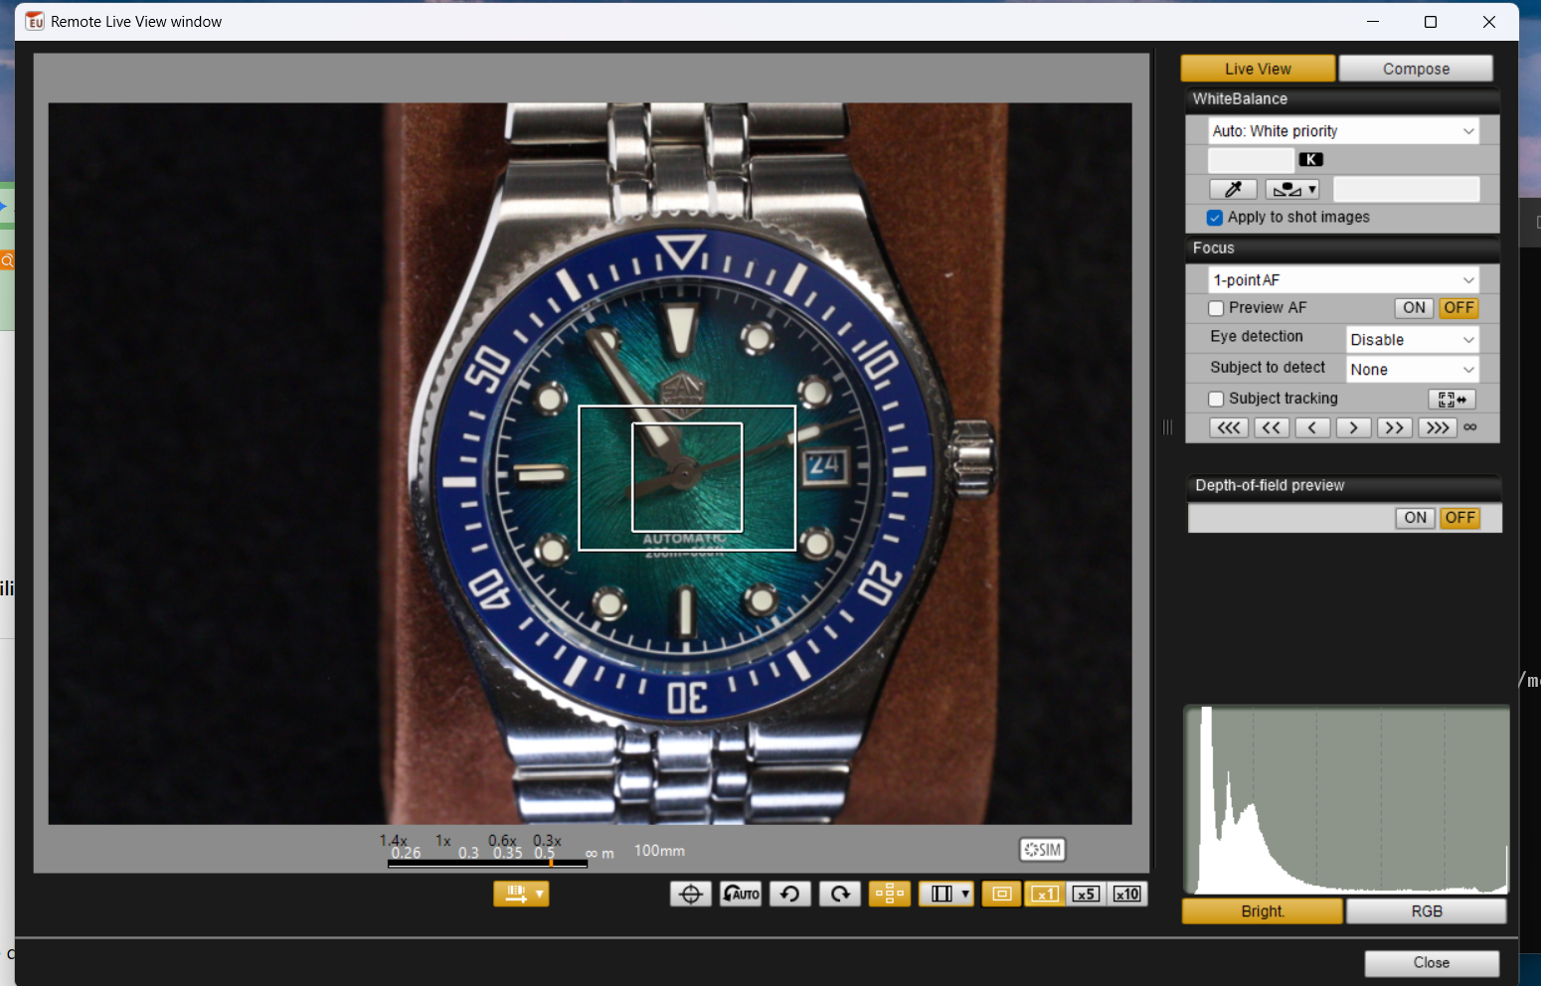

Remote Live View — what matters
Control | Meaning
Lens-distance button | Show/hide focus distance and magnification scale.
Electronic level | Animated pitch/roll overlay; useful for setup, distracting for shooting.
Auto Rotate | Automatic Live View rotation.
Manual rotate | Rotate display when Auto Rotate is off.
AF Point Disp | Show/hide the inner AF square. Must be visible for the lab’s double-click AF workflow.
Aspect ratio | Aspect-ratio / crop information controls.
Outer-frame toggle | Show/hide the magnification frame.
×1 / ×5 / ×10 | Normal, inspection, and critical-focus views.

The double-click focus method
Action | Result
Drag inner AF point | Moves the AF target.
Double-click inside inner AF point | Runs AF; successful One-Shot focus turns the point green.
Double-click somewhere else | Moves the magnification/AF location there and opens 5×; does not yet run AF.
Double-click the relocated AF point | Runs AF at that new location.
Double-click with AF Point Disp off | Magnifies rather than starting AF.
Outer frame only, no inner AF point | Double-click magnifies; outer frame is not an AF point.

Fine focus
Amount | Closer | Farther
Large | I | O
Medium | K | L
Small | < / comma | > / period

LAB SHORTCUT: On this R10/EOS Utility 3.20 setup, the small electronic focus nudges work while the capture window remains in AF. That makes the fastest workflow: AF → 10× → tiny nudge → shoot. Canon’s documented manual-focus procedure uses the capture-window MF setting; both approaches are valid when carefully controlled.

Single-shot sequence
STEP Remote Live View → compose
STEP AF Point Disp ON
STEP Move AF point
STEP Double-click point → green
STEP 10× → verify / nudge
STEP 1× → remote release
STEP Inspect CR3 at 100%

Focus-stack sequence
STEP Place AF point on nearest plane that must be sharp
STEP AF → 10× verify
STEP Focus Bracketing: 30 shots / increment 3 / smoothing ON / Depth Composite ON
STEP Trigger once
STEP Do not touch rig until sequence completes
STEP Inspect composite plus first/middle/last source frames

